Deep Convolutional Network for Handwritten Chinese Character Recognition

1. Introduction

Compared to the task of recognizing handwritten digits and English alphabets, the recognition of handwritten Chinese characters is a more challenging task due to various reasons.

Firstly, there are much more categories for Chinese characters than for digits and English characters.

Secondly, most Chinese characters have much more complicated structures and consist of much more strokes compared to digits or English characters.

Thirdly, handwriting style for Chinese characters varies hugely from person to person.

In this project, we will focus on two specific questions:

1) How will the architecture and depth influence the accuracy of CNN on recognizing handwritten Chinese characters?

2) Does the extracted features make sense in terms of visualization?

2. Data

2.1. Dataset

Test set contains 60 randomly sampled images for each category, and training set contains the rest (approximately 240). In this project, for debugging and comparing different models during training, we further split the original training set into two parts: a training set and a validation set, with training set containing 200 images for each category and validation set contains the rest (approximately 40).

2.2. Preprocessing

So the first step of the data processing is to convert the binary data into image format.

We followed a three-step preprocessing approach: resizing, contrast maximization and image mean subtraction.

1. Network Configurations
   1. 200-class classification

Since we randomly sampled the dataset from the full dataset, we assume that the results on the 200-class dataset is representative enough to draw solid conclusions.

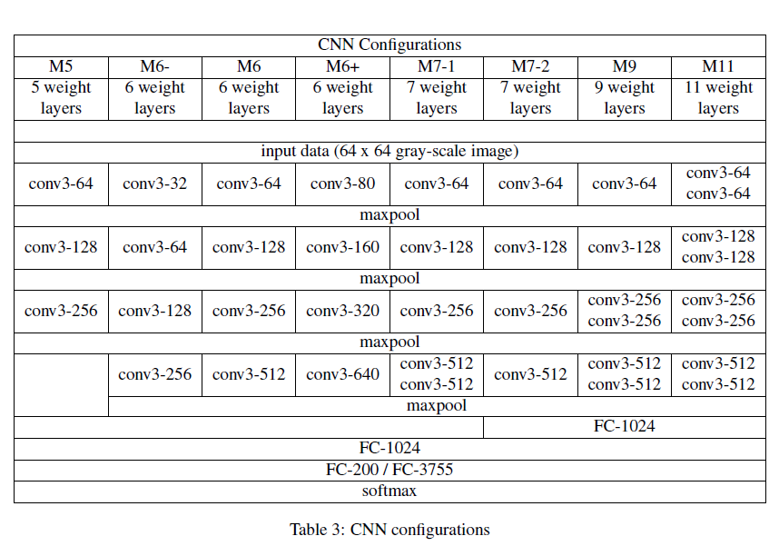

3.2. 3755-class classification

3.3. Visualization

4. Classification Settings

4.1. Implementation

4.2. Training

4.3. Testing

5. Experimental Results

5.1. Classification results

5.2. Network visualization

6. Discussion

7. Related Work

8. Conclusion

Our main findings are that for convolutional neural network with small filter sizes: 1) the deeper the network, the larger the accuracy; 2) increasing the depth gives us diminishing returns in terms of accuracy but highly increases the difficulty of training; 3) increasing the filter number in a moderate range can increase the accuracy; 4) for networks with relatively few convolutional layers, the benefit of adding extra convolutional layer beats that of adding extra fully-connected layer.